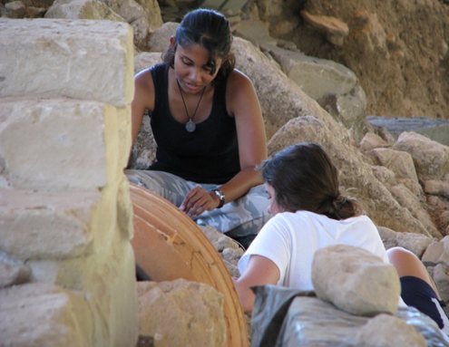

Anthropology
Anagnostis P. Agelarakis
Department Chair
agelarakis@adlephi.edu

Adelphi University
Department of Anthropology
Alumnae Hall Room 218
1 South Avenue
Garden City, NY 11530

T (516) 877-4110 / F (516) 877-4717

anthropology@adelphi.edu
facebook.com/AUANTHRO

What is Anthropology?
Anthropology is the study of humans, past and present. Anthropology builds upon knowledge from the social and biological sciences as well as the humanities and physical sciences. Anthropologists investigate and apply knowledge to solve human problems using a four-field approach:
- Cultural
- Archaeology
- Biological
- Linguistics
________________________________
Degrees Offered
BA Anthropology
Minor Anthropology
The B.A. in Anthropology with an Environmental Anthropology Concentration provides an opportunity for students to complete the degree requirements through courses focused primarily on the interaction of humans with their environment.
________________________________
Benefits of Anthropology Degree
- This is benefit one of anthropology
- This is benefit two
- This is benefit three
- This is benefit four
________________________________
Learning Experiences
Summer Field Programs
- Adelphi in Crete
- Adelphi in Alaska

